Clarifications about Upcoming Simple Convolutional Network Example Video
Correction in "Simple Convolutional Network Example," 1:14:
p=0 means valid convolutions instead of same convolutions.
Setting the padding to zero results in "valid convolutions".

Clarifications about Upcoming CNN Example Video
Around 10:55, Andrew mentions some values of "Activation Size" which will not be present in the table. Please know, the table contains the correct values.
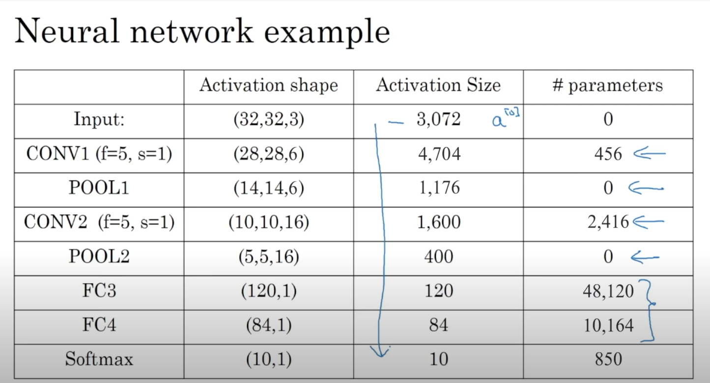

Clarifications about Upcoming Why Convolutions?
0:03/0:30
Starting around 2:15 minute, the number of parameters should have been:
(5*5*3+1)*6 = 456
This is based on the equation:
$(f^{\left[l\right]}×f^{\left[l\right]}×n_{c}^{\left[l − 1\right]}+1)×n_{c}^{\left[l\right]}$
$f^{\left[l\right]}$ is the filter height (and width).
$n_{c}^{\left[l − 1\right]}$ is the number of channels in the previous layer.
$n_{c}^{\left[l\right]}$ is the number of channels in the current layer.
The "1" is the bias term.
(It was (5*5+1)*6=156 in the video.)

